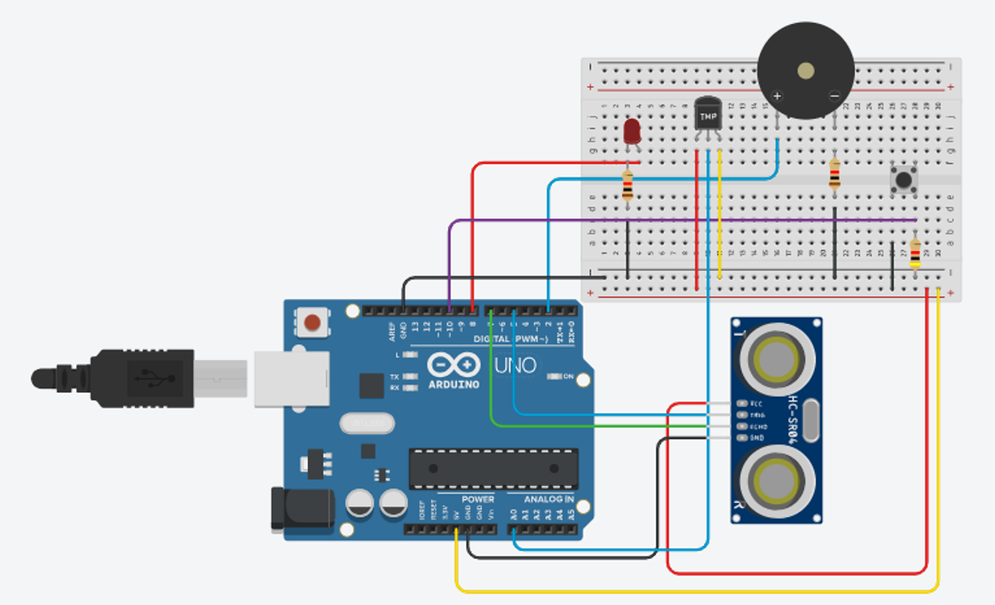

Code: int buzzer = 2;

int i = 0;

int inches = 0;

int cm = 0;

int buttonState = 0;

const int LM35 = A0;

int temperatura;

long readUltrasonicDistance(int triggerPin, int echoPin)

{

pinMode(triggerPin, OUTPUT); // Clear the trigger

digitalWrite(triggerPin, LOW);

delayMicroseconds(2);

// Sets the trigger pin to HIGH state for 10 microseconds

digitalWrite(triggerPin, HIGH);

delayMicroseconds(10);

digitalWrite(triggerPin, LOW);

pinMode(echoPin, INPUT);

// Reads the echo pin, and returns the sound wave travel time in microseconds

return pulseIn(echoPin, HIGH);

}

void setup()

{

Serial.begin(9600);

pinMode(8, OUTPUT);

pinMode(buzzer, OUTPUT);

pinMode(10,INPUT);

}

void loop()

{

int reading = analogRead(LM35); // Lê o valor do sensor

float voltage = reading \* (5.0 / 1023.0); // Converte a leitura em tensão

float temperatureC = voltage \* 100;

buttonState = digitalRead(10);

cm = 0.01723 \* readUltrasonicDistance(5, 7);

if(cm <= 90){

digitalWrite(8, HIGH);

delay(2000);

tone(buzzer, 1000);

delay(30);

Serial.print("Temperatura: ");

Serial.print(temperatureC);

Serial.println("C");

}

if(buttonState == HIGH){

digitalWrite(8, LOW);

delay(2000);

noTone(buzzer);

delay(30);

}

}